Lab 2

**Objectives**

* experiment with page layout using CSS
* experiment with page layout using CSS

**Part 1 (Layout using CSS)**

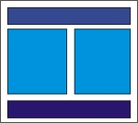

Write the HTML code to produce a page with the layout shown on the right - a header, footer, and 2 columns. The header, footer, and both columns must be composed of at least 2 block-level HTML elements (e.g. paragraph, list, heading). Include a link to the page that you will produce in Part 2.

Use div's and CSS positioning appropriately. Do not use tables for layout.

**Part 2 (Tables)**

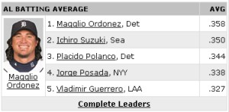

Write HTML code to produce a page with a table that is structurally similar to the table shown in the image on the right but that contains your own data that is relevant to your subject. It should have the same number of rows and columns and require the same use of rowspan and colspan. At least one cell must contain an image. The appearance of the table should be controlled using CSS (not attributes in the HTML tags). The cells must have borders and the rows must alternate in background colors as in the example.